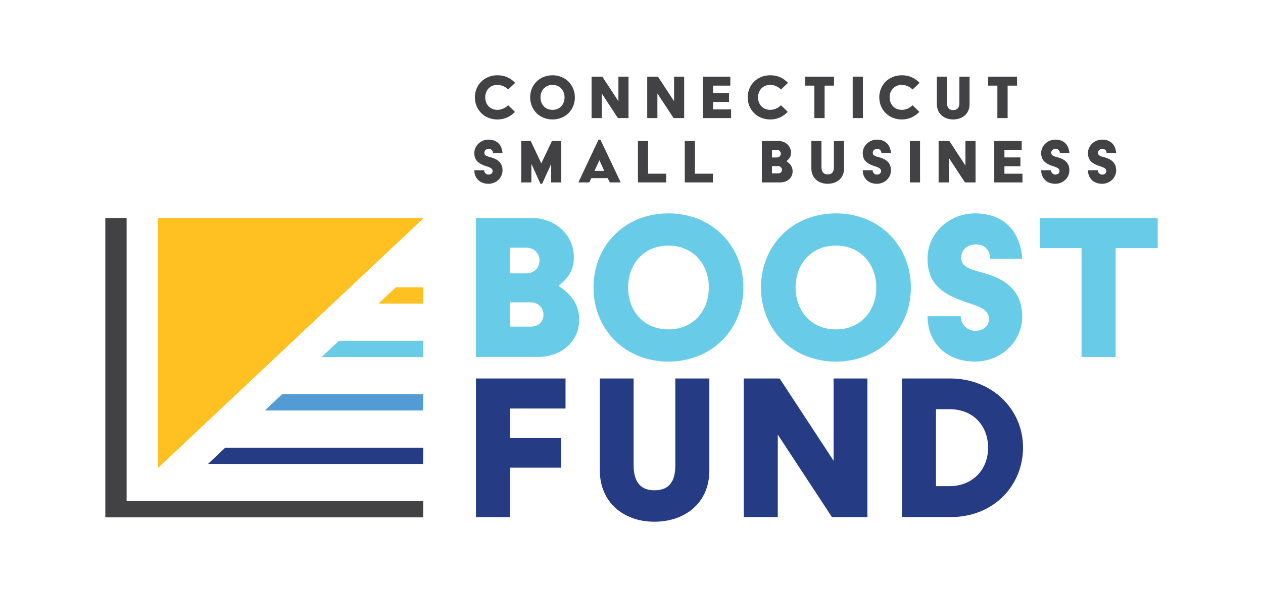

Social media graphics and captions
Use the content below to create posts for your organization’s Facebook, Instagram and LinkedIn accounts. All graphics and videos are available for download in the Dropbox folder here: https://www.dropbox.com/sh/wj1bg5x3pgzyu2z/AABjweTcVZI6DUA-2avOAARAa?dl=0

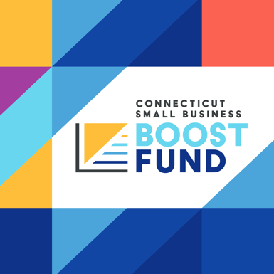 | CAPTION:  The Connecticut Small Business Boost Fund just launched, and we are excited to be able to offer this straightforward, low-interest loan option to our small business and nonprofit clients. Visit CTSmallBusinessBoostFund.org for the details. #CTSmallBusinessBoostFund  LINK: https://www.CTSmallBusinessBoostFund.org
CAPTION:
We are thrilled to be among the handful of Connecticut-based lenders partnering with the Connecticut Department of Economic & Community Development to support small businesses and nonprofits in our region.
#CTSmallBusinessBoostFund
LINK: [link to news article from launch announcement]
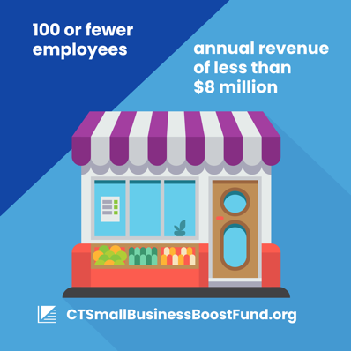 | CAPTION:  Are you a small business owner with 100 or fewer employees and annual revenue of less than $8 million? You may be eligible for this new loan program that’s custom-made for Connecticut’s small businesses and nonprofits. Find out more and pre-apply at CTSmallBusinessBoostFund.org #CTSmallBusinessBoostFund  LINK: https://www.CTSmallBusinessBoostFund.org
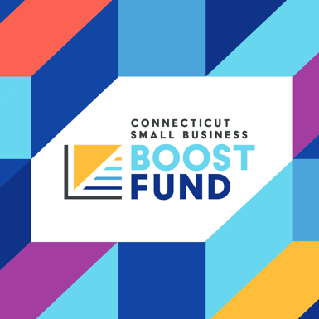 | CAPTION:  #DidYouKnow the Connecticut Small Business Boost Fund was created to get working capital loans into the hands of Connecticut’s small businesses and start ups, providing them with the financial support they need to thrive? Are you a small business that needs assistance? Visit CTSmallBusinessBoostFund.org to find out more. #CTSmallBusinessBoostFund  LINK: https://www.CTSmallBusinessBoostFund.org
CAPTION:
Why are we at [lender name] excited about the Connecticut Small Business Boost Fund? Our mission is to support our community, and we can’t do that without supporting small business owners. This loan could give you a leg up when it comes to growing your business, and we can't wait to help get you started! #CTSmallBusinessBoostFund

LINK: https://vimeo.com/727192379/f398ed3b3e
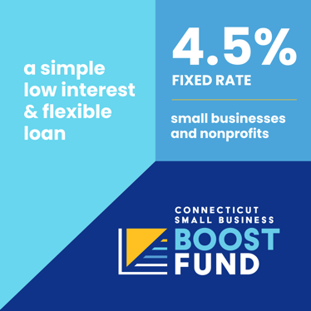 | CAPTION:  We are so excited to bring the Connecticut Small Business Boost Fund loan option to our clients because of its flexibility and low interest rates. If you are a nonprofit or for-profit small business, you can take advantage of the program’s fixed rate of 4.5%. #CTSmallBusinessBoostFund  LINK: https://www.CTSmallBusinessBoostFund.org
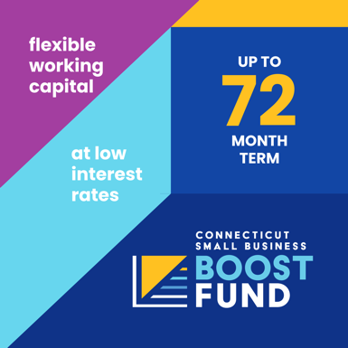 | CAPTION:  Wondering how far your business loan should go? Our community lenders can coach you through what loan terms are best suited to your small business or nonprofit. The Connecticut Small Business Boost Fund offers loans with payback periods of up to 72 months. Contact us today to find out what’s right for your business. #CTSmallBusinessBoostFund  LINK: https://www.CTSmallBusinessBoostFund.org
CAPTION:
Check out this video that provides an overview of the Connecticut Small Business Boost Fund. We're proud to be a partner in this initiative to support Connecticut’s small businesses and nonprofits. #CTSmallBusinessBoostFund

LINK: https://vimeo.com/727192448/6e21a76749

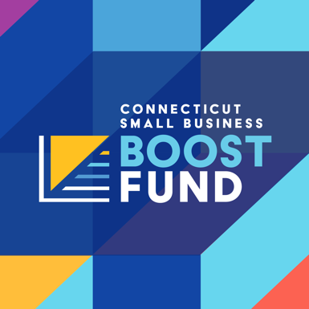 | CAPTION:  #DidYouKnow when you apply for the Connecticut Small Business Boost Fund with us, we sign on to support your business success beyond just the financials? This program is a one-stop shop and can provide you with business support and guidance before, during after the loan process. #CTSmallBusinessBoostFund  LINK: https://www.CTSmallBusinessBoostFund.org
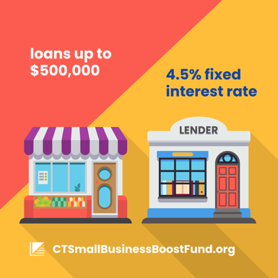 | CAPTION:  If you are a small business or nonprofit that could use support to move your operations forward, we have a great solution for you. Come talk to us about the Connecticut Small Business Boost Fund and see if this flexible, low-interest loan is right for you. #CTSmallBusinessBoostFund  LINK: https://www.CTSmallBusinessBoostFund.org
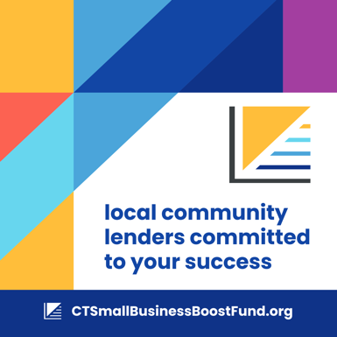 | CAPTION:  Did you know that as a CDFI, we were developed with the mission of serving the community? That's why we offer low rates and flexible loan options – we really are invested in the success of the people in Connecticut. We’re now part of the Connecticut Small Business Boost Fund, a new resource that’s moving businesses forward. Ask us about this great new loan program today! [Phone Number] #CTSmallBusinessBoostFund  LINK: https://www.CTSmallBusinessBoostFund.org
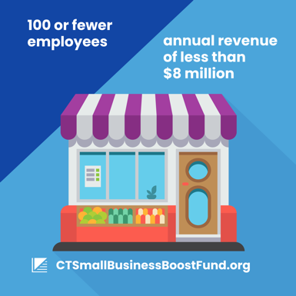 | CAPTION:  Are you a small business owner with 100 or fewer employees and an annual revenue of less than $8 million? We may have a great solution for you: The Connecticut Small Business Boost Fund. Contact us to find out more or pre-apply for loans between $5,000 and $500,000 at CTSmallBusinessBoostFund.org #CTSmallBusinessBoostFund  LINK: https://www.CTSmallBusinessBoostFund.org
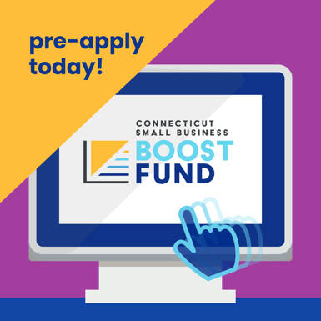 | CAPTION:  Have you pre-applied for a Connecticut Small Business Boost Fund loan yet? Completing the questionnaire at CTSmallBusinessBoostFund.org only takes a few minutes, and if you're eligible, a lender will work with you before, during and after the application process. #CTSmallBusinessBoostFund  LINK: https://www.CTSmallBusinessBoostFund.org
CAPTION:
Supported by the Connecticut Department of Economic & Community Development (@CTDECD), #CTSmallBusinessBoostFund is a great tool for small businesses and nonprofits with 100 or fewer employees and an annual revenue of less than $8 million. Contact us today to find out more about the working capital loan options and see if you are eligible! #CTSmallBusinessBoostFund

LINK: https://www.CTSmallBusinessBoostFund.org
CAPTION:
We are loving how many of our clients have asked about the Connecticut Small Business Boost Fund! We see this as a great tool for small businesses and nonprofits in our community, and are proud to be a partner in this program. Contact us or visit CTSmallBusinessBoostFund.org to find out more. #CTSmallBusinessBoostFund

LINK: https://vimeo.com/727192379/f398ed3b3e

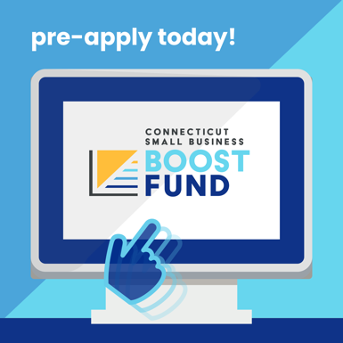 | CAPTION:  Curious if the Connecticut Small Business Boost Fund is a good option for you? Complete the pre-application today at CTSmallBusinessBoostFund.org to see if you are eligible. If you are, we will reach out to talk to you more about your loan options and how this could benefit your business. #CTSmallBusinessBoostFund  LINK: https://www.CTSmallBusinessBoostFund.org

