[Lender Logo] | 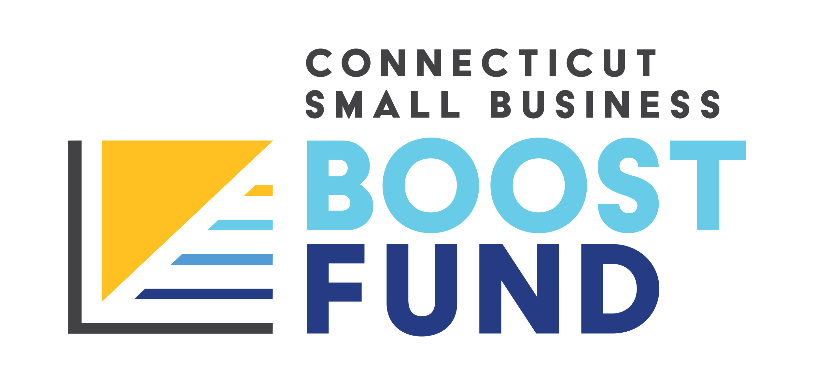

For Immediate Release: [Date]
[Sender contact information]

[Lender Name] joins new program providing Connecticut small businesses and nonprofits with low-interest loans
Working with trusted local lenders, the Connecticut Small Business Boost Fund will support organizations in historically underrepresented communities

[CITY, Conn.] – Small business owners and nonprofits in Connecticut can now apply for low-interest loans between $5,000 and $500,000 through the Connecticut Small Business Boost Fund.

Launched this week, the program is aimed at helping small businesses and nonprofits, particularly those in low-income and historically underbanked communities, get access to flexible working capital. The loans have a fixed, four and a half percent interest rate, no origination fees, and are available to eligible small businesses and nonprofits with operations in Connecticut that have 100 or fewer full-time employees and annual revenues of less than $8 million. Additionally, loans can be spent on a wide variety of needs including equipment, payroll, utilities and rent, eligible refinancing, supplies, marketing and advertising, renovations and other expenses.

Supported by the Connecticut Department of Economic & Community Development, the Connecticut Small Business Boost Fund works with a network of community lenders, including [lender name], that have been serving underrepresented communities for decades, including businesses in distressed municipalities and those led by women, individuals with disabilities, veterans and people of color.

Interested applicants will be able to pre-apply online and, if they qualify, will be matched with a lender. Once matched, the lender will assist the business owner throughout the application process and can connect them with one of the program's technical assistance providers for additional advisory support as needed. This lending model has previously found success in programs based in California, Washington state and New York.

“At [lender], we want to ensure that Connecticut’s small businesses and nonprofits have equitable access to flexible loans and working capital,” said [lender leadership]. “We’re excited to be participating in the Connecticut Small Business Boost Fund and look forward to serving our community through this innovative program.”

The program also offers interested small business and nonprofits guidance from leading technical assistance and business support organizations. These organizations are available to address business owners’ questions and needs, whether it’s before the application process or after the loan is issued.

For more information and to apply, visit CTSmallBusinessBoostFund.org or contact [insert lender contact info] with any questions.

###

About the Connecticut Small Business Boost Fund
The Connecticut Small Business Boost Fund provides access to flexible, low-interest loans and business support services to small businesses and nonprofits across Connecticut. Supported by the Connecticut Department of Economic & Community Development, the Fund is a collaborative partnership of local and national community finance organizations created to link small businesses and nonprofits, especially those in historically underbanked communities, to the financial support they need to thrive. The Fund includes leaders from across sectors including local community lenders, national and state-based nonprofit organizations, corporations, philanthropic donors and investors.

